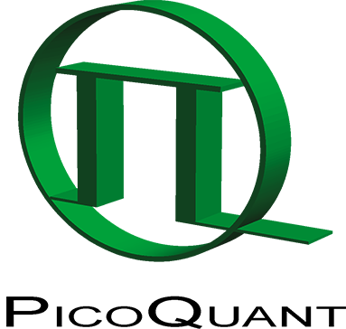
Press Release

Virtual edition of PicoQuant’s Quantum Symposium brings together top scientists from all over the world

Over 120 participants attended and greatly enjoyed this year’s symposium, which was held as an online only event for the first time

Berlin (Germany), 15 October 2020 – This year’s 3rd International Symposium on “Single Photon based Quantum Technologies” was held as a virtual meeting from September 15-17, 2020. The inspiring three day event brought together more than 120 participants from 35 countries to report on and share their latest discoveries.
As in the previous years, the symposium covered a broad range of topics such as single photon sources, quantum information processing, sensing & metrology, single photon detectors, and quantum key distribution. This diversity of topics gives participants the unique opportunity to get insights into different fields of research in optical quantum technologies.
The scientific program encompassed 6 invited talks by renowned scientists, 15 further live presentations, multiple Q&A sessions featuring every speaker, as well as a poster session with 27 contributions. Various virtual rooms provided ample opportunities for discussions, networking, and exchange of ideas.

A summary video made for the particpants is available on YouTube to get an impression of the virtual version of the symposium: https://youtu.be/aJ5_SMe3HfY

About PicoQuant
PicoQuant is a leading research and development company specialized in optoelectronics, which was founded in 1996. The company, headquartered in the science and technology park of Berlin-Adlershof, Germany, is a worldwide leader in the field of single photon counting applications. The product portfolio encompasses picosecond pulsed diode lasers, ultra fast time taggers and photon counters, single photon sensitive detectors, time-resolved confocal and super-resolution fluorescence microscopes, as well as fluorescence lifetime spectrometers. More than 125 people currently work for the PicoQuant group, primarily in its German headquarters, and with strong sales and support teams in the USA and in China.

Attachment
Picture 1: Invited speaker Claire LeGall presented her work on quantum-dot spin qubits.
Picture 2: Group picture

Contact
Nicole Saritas
Marketing Communications
Tel.: +49-30-1208820-607
mkt@picoquant.com
www.picoquant.com

